Database Management Systems

Project

Team Number: #4

Team members:

1. Fatma Mohamed
2. Hassan Ahmed
3. Omar Ahmed
4. Raed Asham

**Users Functionality and Privileges:**

1. Student:
2. Register & Login / Logout
3. Profile Management & stats
4. Have a sketch showing the location of rooms
5. Can search for a room
6. Report any challenges or any malfunctioning in the room. The report should be (delivered / in progress/ solved)
7. Have a monthly quota of 3 hours, If the student is a jta, his quota increases 10 hours.
8. If wants to book a room for a clinic, the doctor of the course should approve, and the TA be notified
9. See a table of locations of the courses he registered in
10. Professor:
11. Register & Login / Logout
12. Profile Management & stats
13. Have a sketch showing the location of rooms
14. Can search for a room
15. Can book a room with unlimited access
16. Report any challenges or any malfunctioning in the room. The report should be (delivered / in progress/ solved)
17. Request a room change from the Rooms Services Team, for lectures and tutorials
18. See a table of locations of the courses he registered in
19. TA:
20. Register & Login / Logout
21. Profile Management & stats
22. Have a sketch showing the location of rooms
23. Can search for a room
24. Have a monthly quota of 20 hours, excluding the tutorials.
25. May request more hours
26. Report any challenges or any malfunctioning in the room. The report should be (delivered / in progress/ solved)
27. Request a room change from the registrar, for tutorials only
28. See a table of locations of the courses he registered in
29. Room services team:
30. Register & Login / Logout
31. Profile Management & stats
32. Have a sketch showing the location of rooms
33. Can search for a room
34. Receives the complaints or any inquires. and handles them.
35. Approves requests (extending quota or room booking)
36. Gives feedback to the cleaning staff, on rooms hygiene. (sees the rooms that has been cleaned)
37. If a room needs special cleaning, they may report it to the cleaning staff and follow the process. The report should be (delivered / in progress/ solved). The room should be closed for any booking
38. May close a room till a problem is resolved. Electrical hazard or whatsoever
39. Cleaning staff:
40. Register & Login / Logout
41. Profile Management & stats
42. Have a sketch showing the location of rooms
43. Can search for a room, the result may appear as a colored square
44. Receives the feedback from the Room services team
45. Receives the reports from the Room services team. The room may be available again only after the cleaning
46. Check the room that has been cleaned
47. Request hygiene supplies from the Room services team
48. registrar:
49. Register & Login / Logout
50. Profile Management & stats
51. Create courses that have professors, TAs, JTAs, and students.
52. Admin:
53. Create & Manage User Accounts
54. Assign & Modify Permissions
55. See overall stats. Number of reports and request handled, and so on

**Entities:**

1. **Student**
2. **Professor**
3. **TA**
4. **Course**
5. **Room**
6. **Admin**
7. **Cleaning staff member**
8. **Registrar member**
9. **Rooms Services Team**
10. **Change Room Request**
11. **Additional Quota Request**
12. **Cleaning Request**
13. **Room Change Request**
14. **Room Booking Request**
15. **Clinic Booking Request**
16. **Report**
17. **Cleaning Supp. Request**

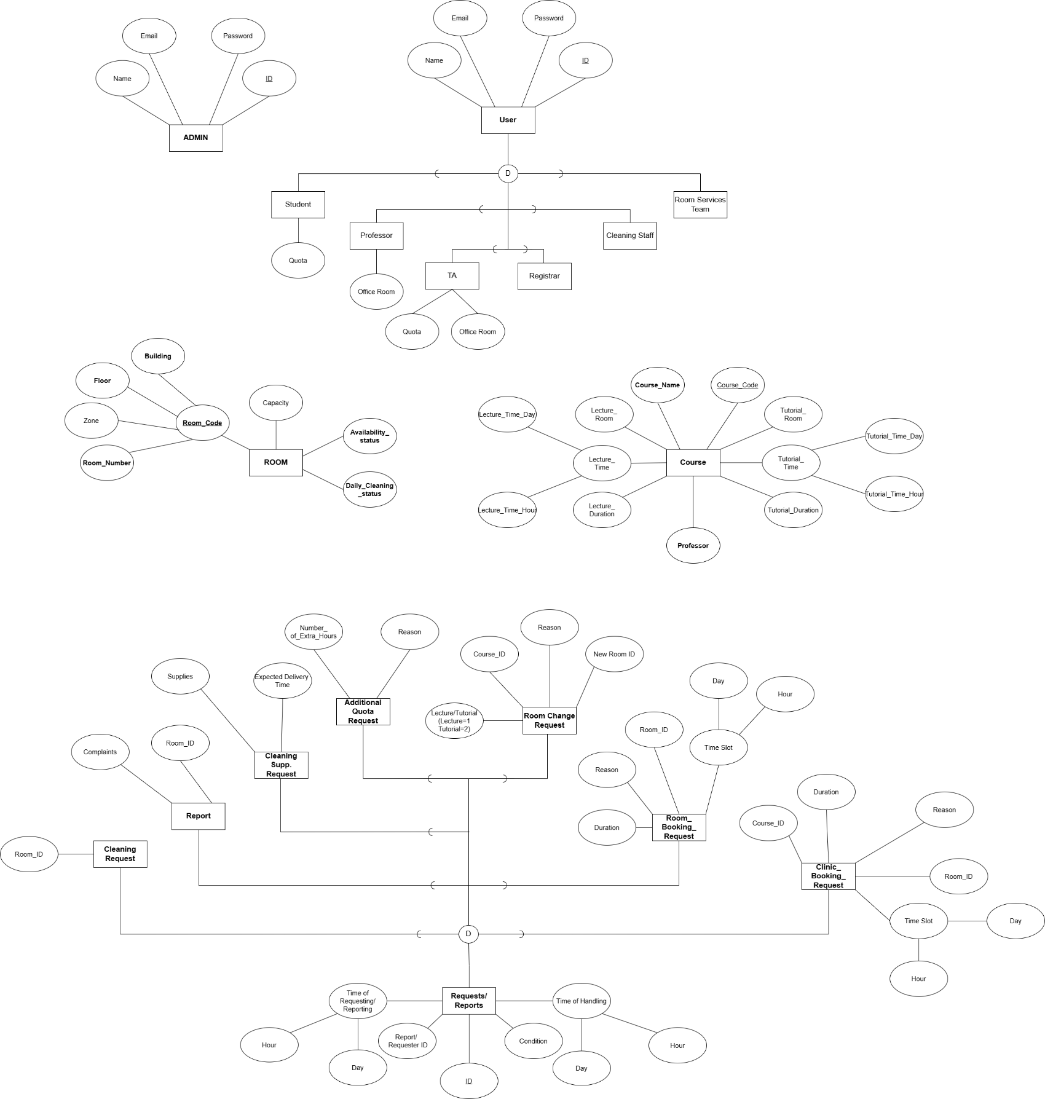**Entity Diagram**

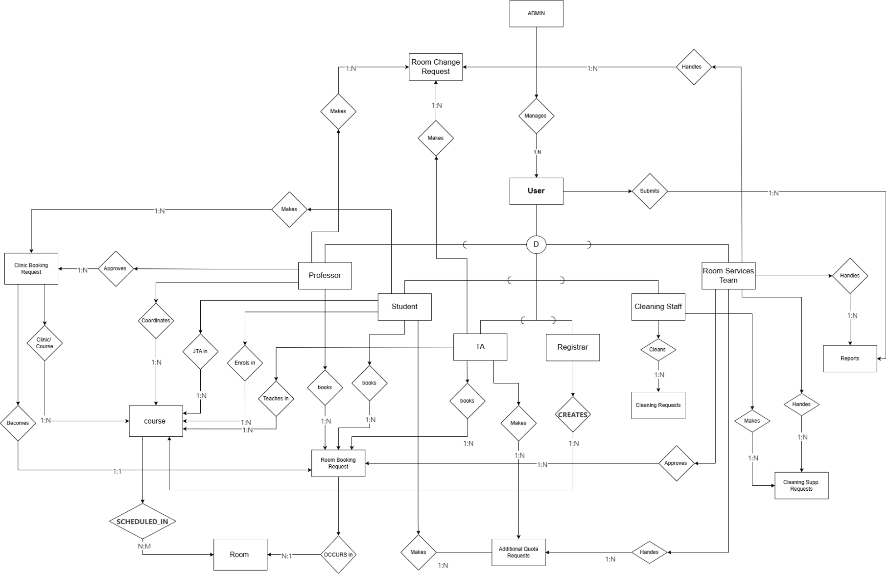**Relationship Diagram**

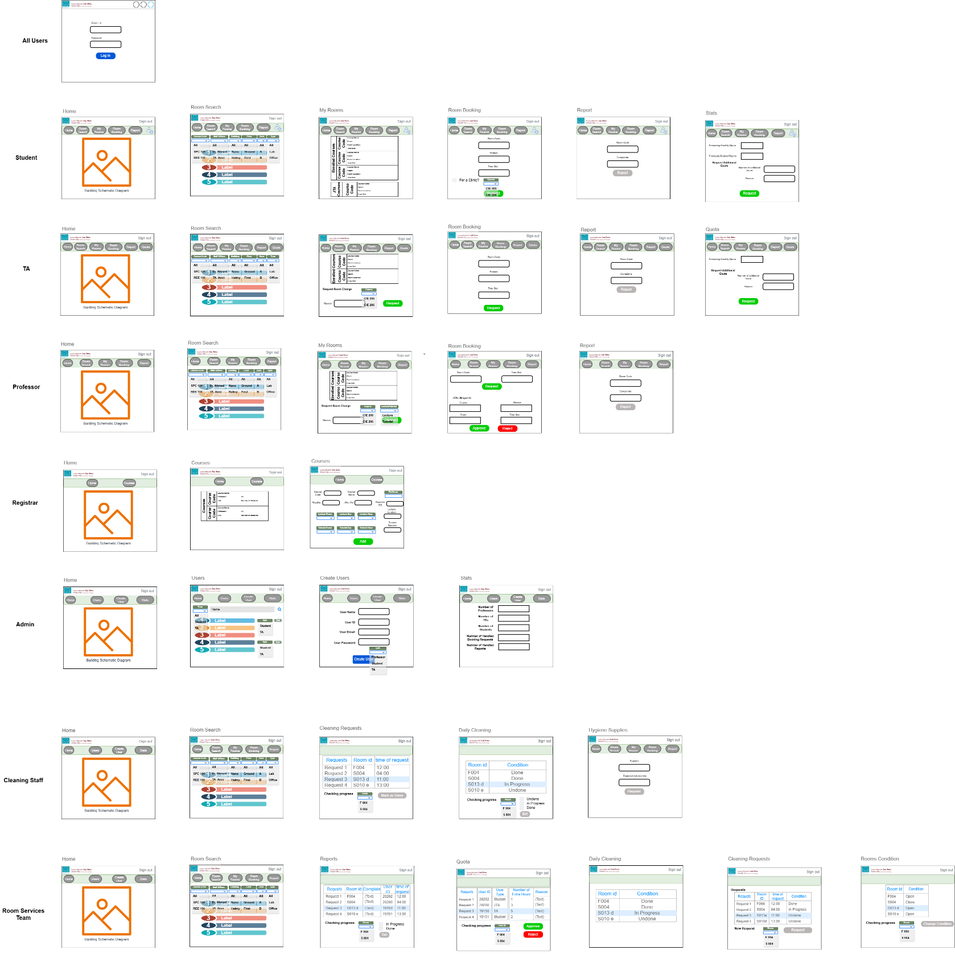**GUI Wireframe**

**Database Schema**